**Assignment4.3**

**Step 1 First we load the file by using command as shown**

**Input_load = LOAD ‘wordcount/wordcount.txt’ as (line:chararray)**;

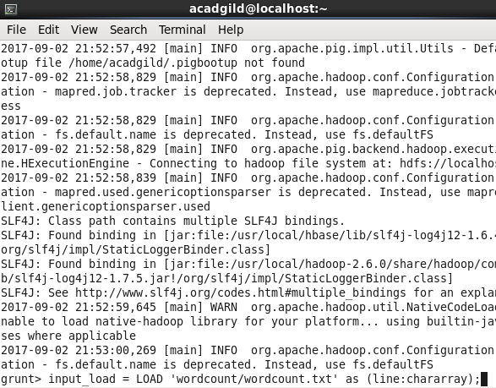

**2)DUMP input_load;**

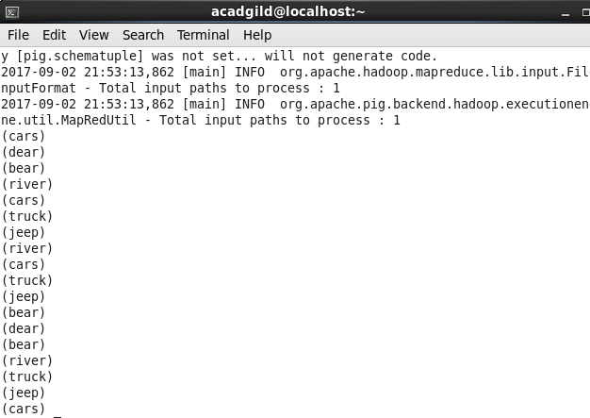

**3) After that we will group it by line using command**

**group_demo = GROUP input_load by line;**



**4)DUMP Group, we will get the output as shown below**

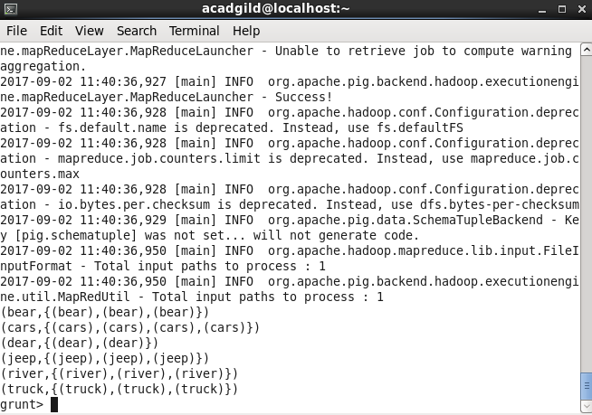

**5) use COUNT Method on group_demo relation to get the result**



